Git Assignment:-
1] Create a folder and initialize init using command as:-
git init
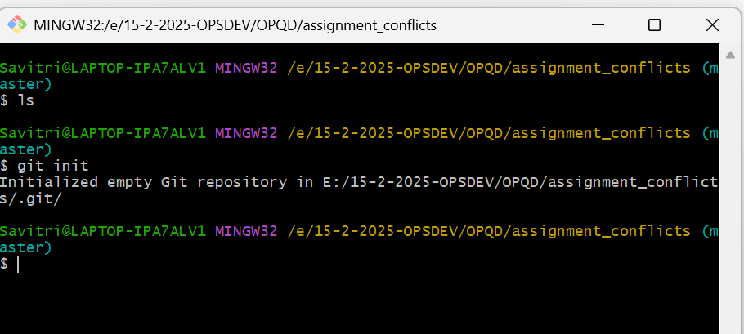

2] Create file, add file ,and commit that file into master branch using below command:-
touch file1
git add file1
git commit -m “adding file 1”
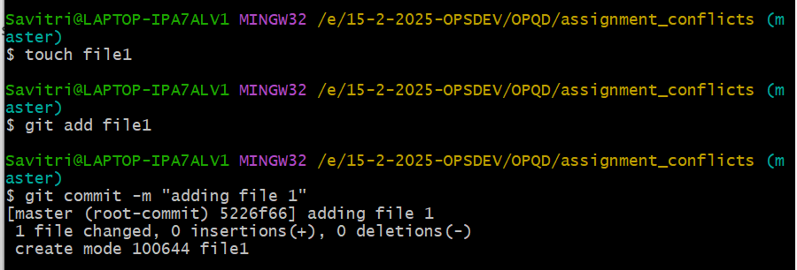

3] Create local branch (source branch will be master & target branch will be newbranch which created), so use below command:-
git checkout -b feature
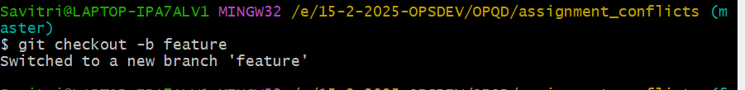

4] Now file1 is created in “master” branch so we created” feature” branch using source as a “master” so file1 is also present in “feature” branch. So edit that and save by using below command:-
nano file1
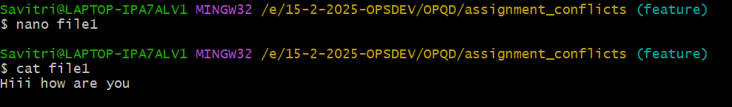
5] Now see changes added or that file is modified or not and also add those changes and commit those changes by using below command:-
git status
git add file1
git commit -m “file 1 is added”
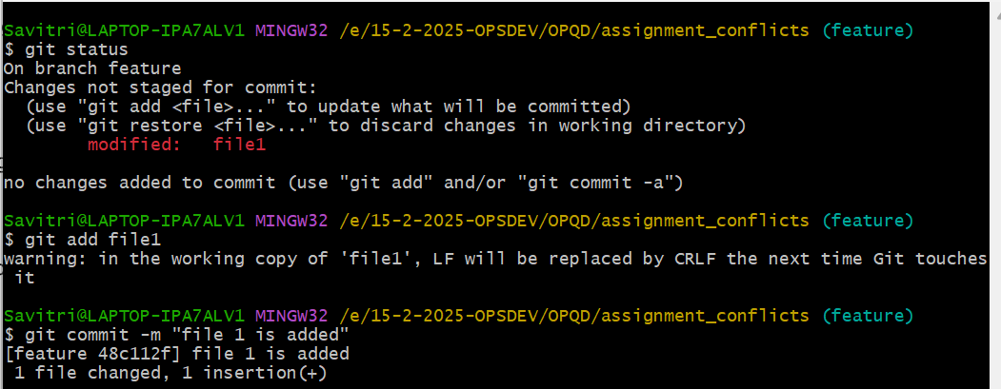

6] Now checkout to “master” branch and edit same file using below command
git checkout master
vi file1
cat file1
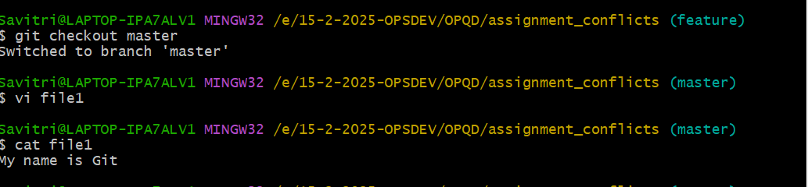

7] again follow steps 5 to add and commit changes
Now I tried to merge “feature” branch changes and facing conflicts .So we have to fix this by using below steps (in screenshot) .Which changes I want that changes I kept and I removed “<<<<<<<HEAD “ as well as “=======” also “>>>>>> feature” and saved file1.:- 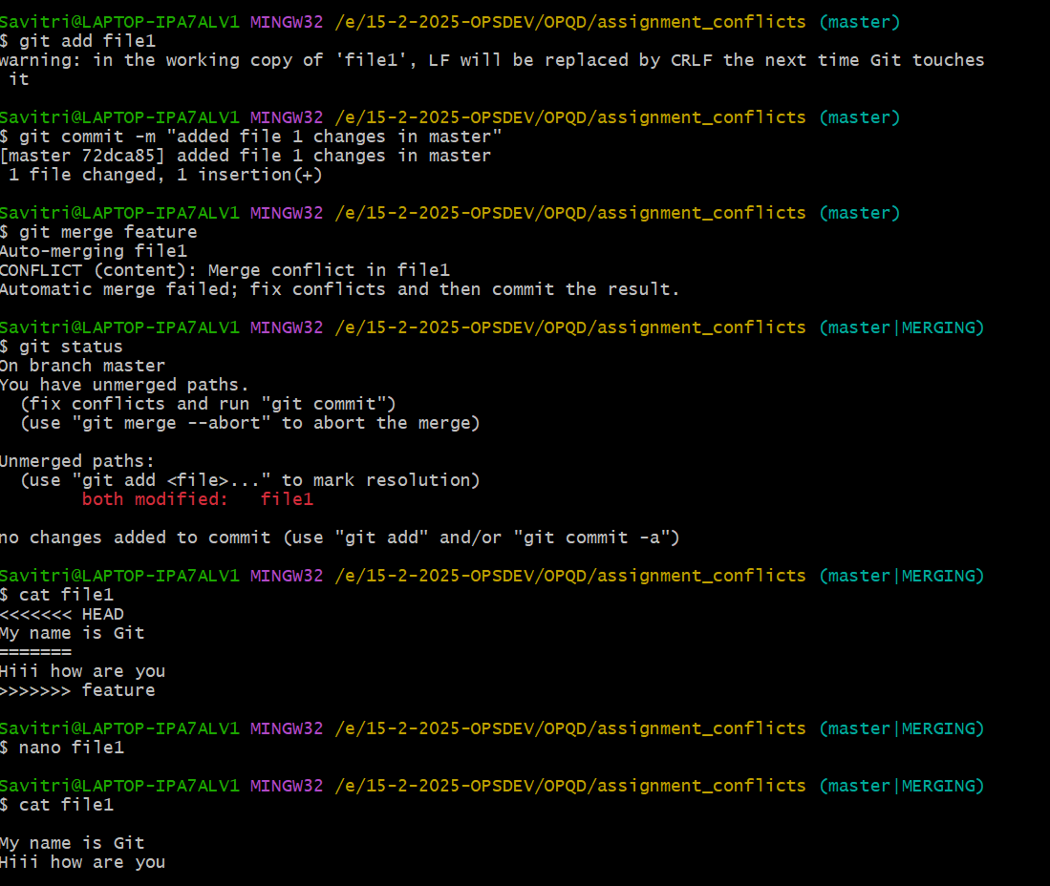

8] so after that add changes and commit
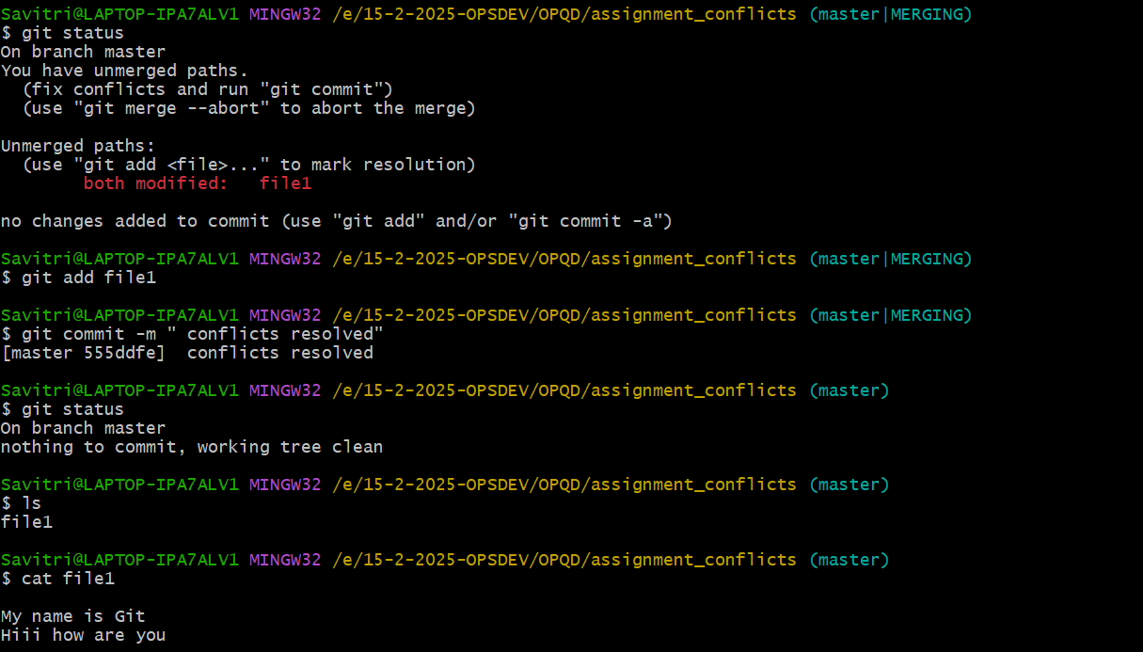
10] check feature branch as well is that changes present in that file or not.

